**RELAIBLE AIRLINES DBDL**

1. **User** **View** **1**: The airline has several types of planes of varying passenger capacities and flight ranges. There are one or more aircraft of each plane type in the airline’s fleet. Each aircraft has a unique serial number that will identify it.

**Entity**: Plane

**Attributes**: SerialNumber, TypeCode, TypeDesc, PlaneCapacity, PlaneRange, ManYear, LastServDate, NextServDate

**Functional** **Dependencies**: SerialNumber → TypeCode, TypeDesc, PlaneCapacity, ManYear, LastServDate, NextServDate, PlaneRange; TypeCode → TypeDesc, PlaneCapacity, PlaneRange

**Primary Key**: SerialNumber

**Special Restrictions**: TypeCode (C8), TypeDesc (C30), PlaneCapacity (D3), PlaneRange (D4), SerialNumber (C12)

**DBDL 3NF**: Plane (SerialNumber, TypeCode, ManYear, LastServDate, NextServDate)

**FK** TypeCode → PlaneType

PlaneType (TypeCode, TypeDesc, PlaneCapacity, PlaneRange)

1. **User View 2**: Pilots are certified only on certain types of planes and the date certified for each plane type needs to be recorded. Also, include the pilot’s birthdate, unique social security number, annual salary and cell phone number. Each scheduled flight is assigned a pilot.

**Entity**: Pilot

**Attributes**: PilotNum, PilotName, PilotBirthdate, PilotSSN, PilotSalary, PilotCellNum, TypeCode, TypeDesc, CertDate

**Functional Dependencies**: PilotNum → PilotName, PilotBirthdate, PilotSSN, PilotSalary, PilotCellNum, TypeCode, TypeDesc, CertDate; TypeCode → TypeDesc; PilotNum, TypeCode → CertDate;

**Primary Key**: PilotNum

**Special Restrictions**: PilotNum (D5), PilotName (C30)

**DBDL 3NF**: Pilot (PilotNum, PilotName, PilotBirthdate, PilotSSN, PilotSalary,

PilotCellNum)

PilotCerts (PilotNum, TypeCode, CertDate)

**FK** PilotNum → Pilot; TypeCode → PlaneType

1. **User View 3:** A flight, which is identified by a unique flight number, has a city of origination and a city of destination but no intermediate stops (these are all direct flights). The time of departure from the origination city and arrival at the destination city are also recorded. An actual, scheduled flight has a date, an aircraft, and a pilot in addition to all of the above information for a flight. A scheduled flight is uniquely identified by the combination of a flight number and date. Note: There is only one airport per specific city, state.

**Entity**: Flight

**Attributes**: FlightNum, OriginCity, DestCity, DepartTime, ArriveTime, FlightDate, FlightPlane, FlightPilot

**Functional Dependencies**: FlightNum → OriginCity, DestCity, DepartTime, ArriveTime, FlightDate, FlightPlane, FlightPilot; OriginCity/DestCity → City; FlightNum, FlightDate → FlightPlane, FlightPilot

**Primary Key**: FlightNum

**Special Restrictions**: FlightNum (D3), CityCode (C3), CityName (C30), CityState (C2), AirportDesc (C30), City should be in city name order

**DBDL 3NF**: Flight (FlightNum, OriginCity, DestCity, DepartTime, ArriveTime)

**FK** OriginCity/DestCity → City

**SK** OriginCity and DestCity

SchFlight (FlightNum, FlightDate, FlightPlane, FlightPilot, AvailableSeats)

**FK** FlightNum → Flight; FlightPlane → Plane; FlightPilot → Pilot

**SK** FlightNum, FlightDate

City (CityCode, CityName, CityState, AirpotDesc)

1. **User View 4**: Passengers are booked on scheduled flights. Passengers make a reservation but are not assigned specific seats. For purposes of this database, we will assume that passengers are uniquely identified by an ID of some sort generated by the database system. Also needed for passengers is the first and last name, the main phone number, street address, city, state, zip, email (if available) and birthdate. Note: a single passenger can book multiple tickets but would have to give the passenger information for each ticket booked.

**Entity**: Passenger

**Attributes**: PassengerID, PassFirstName, PassLastName, PassBirthdate, PassPhoneNum, PassAddress, PassEmail, PassTickets

**Functional Dependencies**: PassengerID → PassFirstName, PassLastName, PassBirthdate, PassPhoneNum, PassAddress, PassEmail

**Primary Key**: PassengerID

**Special Restrictions**: None

**DBDL 3NF**: Passenger (PassengerID, PassFirstName, PassLastName, PassBirthdate,

PassPhoneNum, PassAddress, PassEmail)

Booking (PassengerID, FlightNum, FlightDate)

**FK** PassengerID → Passenger; FlightNum, FlightDate → SchFlight

**CUMULATIVE DESIGN**

Plane (SerialNumber, TypeCode, ManYear, LastServDate, NextServDate)

**FK** TypeCode → PlaneType

PlaneType (TypeCode, TypeDesc, PlaneCapacity, PlaneRange)

Pilot (PilotNum, FName, LName, PilotBirthdate, PilotSSN, PilotCellNum, PilotSalary)

**AK** SSN

PilotCerts (PilotNum, TypeCode, CertDate)

**FK** PilotNum → Pilot; TypeCode → PlaneType

Flight (FlightNum, OriginCode, DepartTime, DestCode, ArriveTime)

**FK** OriginCode/DestCode → City

SchFlight (FlightNum, FlightDate, FlightPlane, FlightPilot)

**FK** FlightNum → Flight; FlightPlane → Plane; FlightPilot → Pilot

City (CityCode, CityName, CityState, AirpotDesc)

**SK** CityName

Passenger (PassengerID, PassFirstName, PassLastName, PassBirthdate, PassPhoneNum, PassAddress, PassEmail)

Booking (PassengerID, FlightNum, FlightDate)

**FK** PassengerID → Passenger; FlightNum, FlightDate → SchFlight

**Special Restrictions:** Seats available is a derived attribute. Sum of reservations made for a specific scheduled flight is deducted from the capacity of the plane type.

**DATA STRUCTURE DIAGRAM**

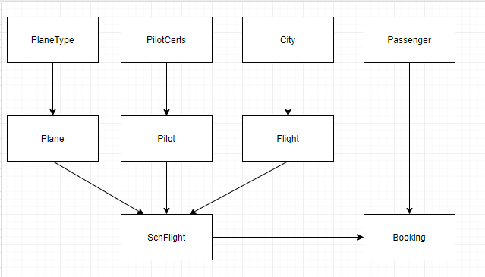

**PROJECT LOG**

